# Chess Training Sesssion – Rugeley Chess Club Sunday 7th July 2013

## Intro

What we will look at, how we will do it, how we will summarise.

We are going to look at the Sicillian Defence for white and in particular the Dragon and in particula r the Yugoslav attack. What are the options and which is best:

* Closed with g3
* Closed with Bb5
* 2.F4 or 2.Nc3 with f4
* Morra Gambit
* Alapin
* Open Sicillian – the best try and used by most top players

So we shall look at the Yugoslav attack starting from Whites 9th move options.

## Lesson

Play over some games – Cath v Dave & P Stayley v Dave

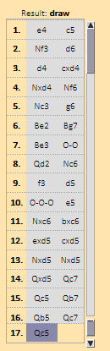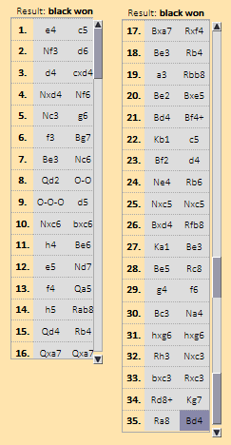

2 more games here – one where white wins, one where black wins.

**(33) Polgar,Judit (2711) - Carlsen,Magnus (2775) [B78]**

Mainz Classic rap Prelim Mainz (3), 01.08.2008

1.e4 c5 2.Nf3 d6 3.d4 cxd4 4.Nxd4 Nf6 5.Nc3 g6 6.Be3 Bg7 7.f3 Nc6 8.Qd2 0–0 9.Bc4 Bd7 10.0–0–0 Rc8 11.Bb3 Ne5 12.g4 b5 13.g5 b4 14.Nce2 Nh5 15.f4 Nc4 16.Bxc4 Rxc4 17.b3 Rc7 18.Ng3 Rc3 19.Nxh5 gxh5 20.Kb1 Qa5 21.f5 Rfc8 22.f6 e5 23.Nf5 Bxf5 24.exf5 Rxc2 25.Qxc2 Rxc2 26.Kxc2 Qxa2+ 27.Kd3 Bf8 28.Rc1 d5 29.Rhd1 Qb2 30.Bd2 Qxb3+ 31.Ke2 e4 32.Be3 Qb2+ 33.Ke1 Qxh2 34.Rxd5 Qb8 35.Rcd1 b3 36.Rd8 Qb4+ 37.Kf2 b2 38.Rb1 Qa5 39.Ra8 Qxf5+ 40.Ke1 Qa5+ 41.Kf2 Qc7 42.Rd1 Qh2+ 43.Ke1 Qh1+ 44.Ke2 Qxd1+

0–1

**(26) Anand,Viswanathan (2798) - Carlsen,Magnus (2775) [B78]**

Mainz Classic rap fin Mainz (1), 03.08.2008

1.e4 c5 2.Nf3 d6 3.d4 cxd4 4.Nxd4 Nf6 5.Nc3 g6 6.Be3 Bg7 7.f3 Nc6 8.Qd2 0–0 9.Bc4 Bd7 10.Bb3 Rc8 11.0–0–0 Ne5 12.Kb1 a6 13.h4 h5 14.g4 hxg4 15.h5 Nxh5 16.Rdg1 Qa5 17.Bh6 Rxc3 18.Bxg7 Kxg7 19.Rxh5 Rxb3 20.Qxa5 Rxb2+ 21.Ka1 gxh5 22.f4 Be6 23.Nxe6+ fxe6 24.fxe5 Rb5 25.Qc7 Rxe5 26.Qxe7+ Rf7 27.Qxd6 Rxe4 28.Rh1 Rf5 29.Qe7+ Kg6 30.Qe8+ Kg7 31.Rd1 Rd5 32.Rxd5 exd5 33.Qxh5 b5 34.Qg5+ Kh7 35.Qxd5 Ra4 36.Qg5 Rc4 37.Kb2 Rb4+ 38.Kc1 Ra4 39.a3 Rc4 40.Kd2 Rd4+ 41.Ke1 Ra4 42.Kf1 Rc4 43.Kg1 Rc6 44.Qd5 Rg6 45.a4 bxa4 46.Qd7+ Kh6 47.Qxa4 Kg5 48.c4 Kf5 49.c5 Ke5 50.Qd7

1–0

Split into 2 teams and have a game on the big board

## Summary

Summarise here